Automated Watering System

Done By

SOURAV MANDOL (1607044)

SUMAN MIA(1607045)

**OBJECTIVES:**

1)Making watering system automated.

2) Ensure enough moisture essential for plant growth**.**

3) Cool the soil to provide a suitable surrounding.

4) Soften the tillage pan.

5) To reduce the cost of labor.

6) Saving time is one of the major purpose of this project.

7) To save the plan being rotten because of water.

**INTRODUCTION:**

In this project, we are talking about an automated system that includes whole watering system.

An automated watering system is such a system that starts watering to plants by measuring soil moisture through soil moisture sensor. In this project we will have some extra benefits. We don’t need to control this watering, because the device will make this automatically when it will need it.

**Hardware Materials:**

1)Arduino (Uno)-1p 6)9V battery-1P

2)Motor driver (L293D)-1P 7) Transistor (BC547)-1p

3)Soil Moisture Sensor -1p 8) Buzzer-1P

4)12V DC water Pump-1P 9) pipe-4 ft

5)Lipo Battery -1P 10) Wires-as required.

**Circuit Diagram:**

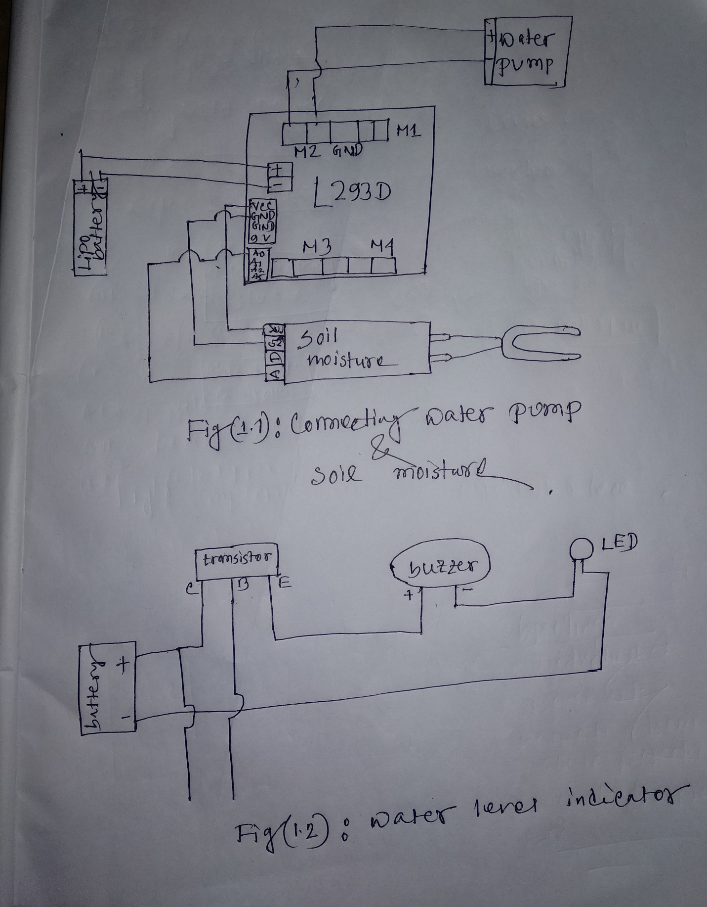

**Code:**

#include <AFMotor.h>

#include <Servo.h>

// DC motor on M2

int pin=A5;

AF_DCMotor motor(2);

void setup() {

pinMode(pin,OUTPUT);

Serial.begin(9600);

motor.setSpeed(1000);

motor.run(RELEASE);

}

void loop()

{int sensorValue = analogRead(A0);

Serial.println(sensorValue);

delay(1);

if(sensorValue>300)

{

motor.run(FORWARD);

}

else

motor.run(RELEASE);

}

**Improvements & Variations:**

First of all we have used Arduino shield (motor driver L293D) .For this reason we can user any water pump. Because we can supply at most 23v without any damages to the Arduino. That is better than using relay.

In this project we have a another 2nd part called water level detector. It will help to detect the water level. when a water tank will be filled up then the buzzer will turn on.

**Conclusion:**

We have tested the project several times. The water pump and moisture sensor work successfully and the buzzer gives it signal when the water level is equal or greater than a specific level. When we give power supply to Arduino, it works properly via motor driver. In this way, the objectives of this project come out fulfilled.